- This week's UK public finances data suggested that borrowing is on track to undershoot the Office for Budget Responsibility's 2023-2024 forecast. But the OBR's take on the fiscal outlook five years out is what matters for the policy stance. We think lower gilt yields and market expectations for Bank Rate will provide the Chancellor with slightly more room for manoeuvre.
- We're concerned about the state of fiscal policymaking. There are better options than the current fiscal rules, while operating with a tiny margin for error leaves the Chancellor vulnerable to changes in market pricing. We fear the hunger for pre-election tax cuts will mean the temptation to assume an even more implausible post-election spending squeeze proves impossible to resist.
The Budget is less than two weeks away, and this week's only official data release was the final set of public finances figures that will feed into the Office for Budget Responsibility's fiscal forecasts.
January typically reports the strongest set of figures in a fiscal year because it's the month when most self-assessment payments are made. This January's figures were a little underwhelming – the surplus on the public sector net borrowing measure was £16.7bn, £1.6bn smaller than the OBR's forecast. But large revisions to previous months meant that borrowing over the first ten months of the fiscal year was just over £9bn lower than the OBR's Autumn Statement projection. Though central government revenues have slipped behind expectations, the shortfall in spending has been even larger, mainly due to the impact of lower RPI inflation on debt interest payments (Chart 1).
It's unlikely that this week's data will have much impact on the OBR's five years ahead judgement, which is ultimately all that matters for policy decisions. But there's two key developments since November's Autumn Statement that could, both pointing in a favourable direction for the Chancellor. The OBR will likely adopt the ONS' new, higher, population projections which, all else equal, should raise projections for GDP, employment, and tax receipts.

Chart 1: Lower-then-expected government spending is likely to cause borrowing to undershoot this year
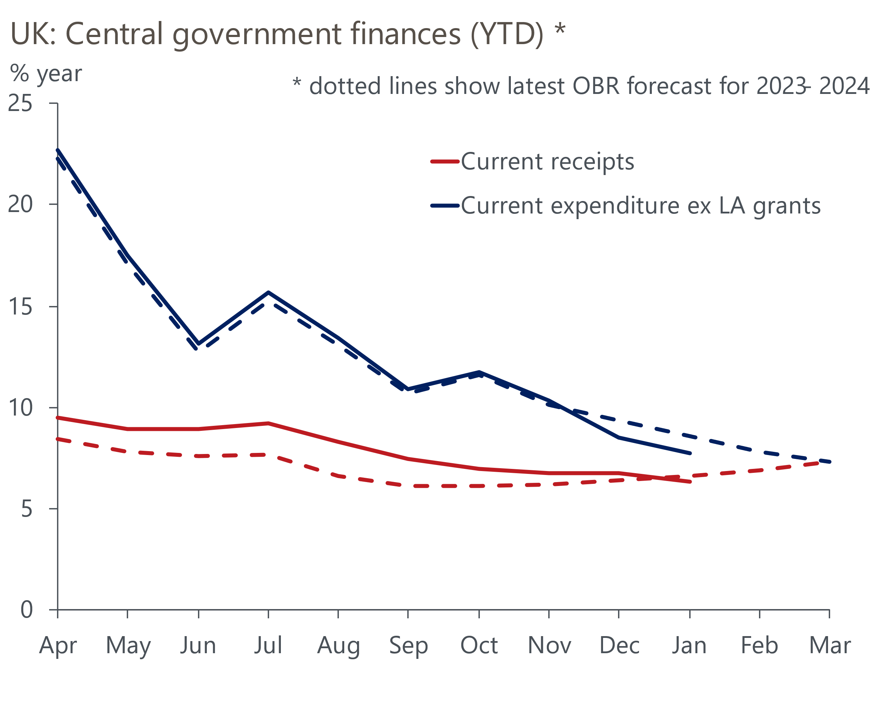
Sources: Oxford Economics, Haver Analytics & OBR

Meanwhile, falls in gilt yields and market expectations for the path of Bank Rate should reduce the OBR's forecasts for debt servicing costs. For the Autumn Statement, the OBR used a ten-day window that finished six weeks before the fiscal event. Applying a similar timetable for the Budget suggests the assumptions for gilt yields and market expectations for Bank Rate will be around 50bps and 20bps lower (Chart 2). This should equate to a reduction in debt servicing costs in 2028-2029 of around £7bn.
Chart 2: Lower market pricing should give the Chancellor an extra £7bn to play with
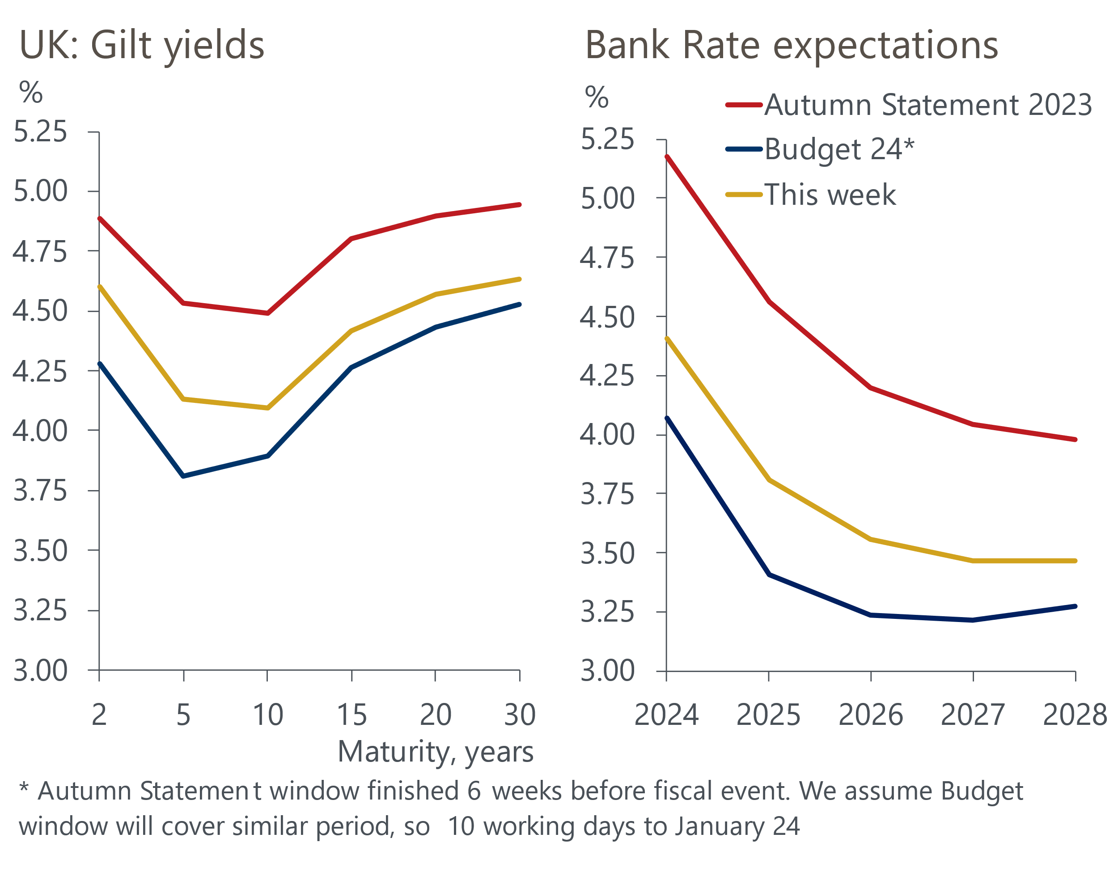
Source: Haver Analytics
Against that backdrop, Treasury briefings that the Chancellor won't have any extra headroom look a little odd. We think this is largely expectations management for Conservative MPs hungry for large tax cuts. If not, there is one potential explanation. The OBR may offset the impact of stronger population growth by reining back its assumption for productivity – as our recent report argued, its current projection looks too optimistic, particularly given the experience of the past 15 years. The OBR also published a report last year that admitted it had been persistently too optimistic on GDP growth, though having not acted on those findings in November, it would look a bit odd to do so now. But on balance, we think the OBR's forecasts will be slightly more favourable to the Chancellor.
Standing back to the survey the scene, fiscal policymaking is in a bad place. The choice of fiscal rules and the Chancellor's decision to operate with a wafer-thin margin for error against the main rule has created two interrelated problems. First, a vulnerability to relatively small changes in the underlying drivers of the fiscal forecasts, which encourages short-termism over a long-term strategy. And second, an incentive to make unrealistic assumptions about government departmental spending in the medium-term, in the knowledge that the OBR will take these assumptions at face value. Both issues are exacerbated at the current time by the proximity of the election. We expect the Budget will provide a clear demonstration of these problems. As usual, the Chancellor will need to find money to stop fuel duty rising. And he may cut headline personal tax rates now, notionally financed by ever more unrealistic post-election spending cuts.
The Chancellor is a little fortunate that markets' recent hawkish pivot on the interest rate outlook has happened since the OBR probably locked its financial assumptions. Four members of the Monetary Policy Committee gave evidence to the Treasury Select Committee this week, offering similar messages to the February MPC meeting. Governor Bailey played down the importance of weak GDP data in H2 2023, pointing to the recent strength of business surveys. This is consistent with our view that the growth outlook is strengthening. A further pickup in the composite PMI in February's flash survey added to this impression.
On inflation, the Governor said "we don't need obviously inflation to come back to target before we cut interest rates". Inflation should be back below 2% in April, after the news that the Ofgem energy price cap will fall 12% that month. So taken literally, Bailey's comments suggest a March cut is in play. But context is important, and Bailey was pushing back against concerns from some MPs that the MPC would be behind the curve in loosening policy. The remainder of the testimony was consistent with our view that while a May cut is plausible, June looks the most likely timing at the moment.

The week ahead
The end of last year saw a gradual recovery in housing activity take root, in response to the fall in quoted mortgage rates since mid-summer. We think this is likely to have continued in early-2024 and forecast that mortgage approvals edged up to 51,500 in January. But this would still be nearly 18% down on the 2022 average, reflecting the fact that while mortgage affordability has improved in recent months, it's still very stretched relative to historical norms. Net mortgage lending was negative in December, following low levels of mortgage approvals in early autumn. But with approvals having subsequently recovered, we expect net advances to have risen to £0.7bn in January.
Though gross unsecured lending continued to rise in December, net lending fell sharply because of a spike in repayments. But repayments can be very volatile from month-to-month and, on the assumption that they returned to more normal levels in January, we think net unsecured lending will have risen to £1.6bn.
The flash S&P Global/CIPS manufacturing survey for February reported a much smaller decline in manufacturing output than in recent months, although there was only a marginal increase in the PMI. We expect next week's final results to show the PMI close to the flash estimate of 47.1.
Table 1: Week ahead calendar
Date | Events | Period | Measure | Unit | Previous | Forecast
w/c Feb 26 | Nationwide house prices | Feb | m/m | % | 0.7 | -0.4
w/c Feb 26 | Nationwide house prices | Feb | y/y | % | -0.2 | -0.1
Feb 29 | Mortgage approvals | Jan | Level | 000s | 50.5 | 51.5
Feb 29 | Mortgage lending | Jan | Net lending | £bn | -0.8 | 0.7
Feb 29 | Consumer credit | Jan | Net lending | £bn | 1.2 | 1.6
Mar 1 | S&P Global/CIPS manufacturing | Feb | PMI | % bal | 47.1 | 47.1
Source: Oxford Economics

Key forecasts
Table 2: UK forecast overview
(Annual percentage changes unless specified)
 | 2022 | 2023 | 2024 | 2025 | 2026 | 2027
GDP | 4.3 | 0.1 | 0.4 | 1.8 | 2.0 | 1.7
Private consumption | 4.8 | 0.3 | 0.6 | 2.2 | 2.2 | 1.8
Fixed investment | 8.0 | 2.9 | -2.8 | 0.4 | 2.6 | 2.2
Government consumption | 2.3 | 0.6 | 3.9 | 2.5 | 1.6 | 1.5
Exports of goods and services | 9.0 | -1.4 | -1.0 | 2.8 | 2.4 | 1.7
Imports of goods and services | 14.6 | -1.6 | 1.1 | 3.3 | 3.0 | 2.0
Industrial Production | -3.5 | -0.3 | 0.2 | 0.9 | 1.5 | 1.1
Consumer prices | 9.1 | 7.3 | 2.1 | 2.1 | 2.2 | 2.1
Unemployment rate (%) | 3.9 | 4.0 | 4.0 | 3.9 | 3.8 | 3.8
Current a/c balance (% of GDP) | -3.1 | -2.8 | -2.9 | -2.9 | -3.0 | -2.9
Government balance (% of GDP) | 4.4 | 5.2 | 3.3 | 2.6 | 2.0 | 1.4
Cen. bank policy rate (%, EOP) | 3.50 | 5.25 | 4.50 | 3.50 | 2.50 | 2.00
10yr govt. bond yield (%, EOP) | 3.67 | 3.54 | 3.76 | 3.46 | 3.02 | 2.85
Exchange rate (US$ per £, EOP) | 1.20 | 1.27 | 1.27 | 1.29 | 1.32 | 1.35
Exchange rate (euro per £, EOP) | 1.13 | 1.15 | 1.17 | 1.16 | 1.15 | 1.15
Source: Oxford Economics
Table 3: Quarterly forecasts for the UK
 | 2023 |  |  |  | 2024
 | Q1 | Q2 | Q3 | Q4 | Q1 | Q2 | Q3 | Q4
GDP (% year) | 0.3 | 0.3 | 0.2 | -0.2 | -0.2 | 0.1 | 0.5 | 1.2
CPI inflation (% year) | 10.2 | 8.4 | 6.7 | 4.2 | 3.4 | 1.6 | 1.8 | 1.8
Bank Rate (%, EOP) | 4.25 | 5.00 | 5.25 | 5.25 | 5.25 | 5.00 | 4.75 | 4.50
10yr gilt yield (%, EOP) | 3.47 | 4.39 | 4.46 | 3.54 | 4.00 | 3.86 | 3.81 | 3.76
US$ per £ (EOP) | 1.24 | 1.27 | 1.22 | 1.27 | 1.26 | 1.26 | 1.26 | 1.27
Euro per £ (EOP) | 1.14 | 1.17 | 1.15 | 1.15 | 1.17 | 1.17 | 1.17 | 1.17
Source: Oxford Economics

Latest Country Economic Forecast:
February 20, 2024

Recent publications

Data Insights
PMIs signal stronger activity and price pressures
Extra fiscal headroom is looking more limited
Retail sales rebounded in January
GDP fell again in Q4
Inflation held firm in January, but will soon fall sharply

Research Briefings
Slowing labour supply puts the onus on productivity gains
Tight labour market and firm pay growth will worry the MPC
BoE suggests rate cuts are coming…but not quite yet
Housing market on course for a soft landing
MPC preview – A change of tone, but not of policy

Contacts

Oxford Economics' UK team
- Andrew Goodwin - Chief UK Economist - agoodwin@oxfordeconomics.com
- Edward Allenby - UK Economist - eallenby@oxfordeconomics.com

